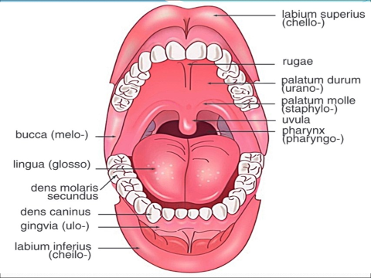
cavitas oris – og‘iz bo‘shlig‘i
gingiva – milk
palatum – tanglay
palatum durum –qattiq tanglay
palatum molle –yumshoq tanglay
lingua – til
labium – lab
labium superius-yuqori lab
labium inferius-pastki lab
bucca – lunj
mandibula – pastki jag‘
maxilla – yuqori jag‘
articulatio temporomandibularis – chakka-pastki jag‘ bo‘g‘imi
alveolus dentis – tish katagi(alveolasi)
uvula-tilcha
tonsilla-bodomcha bez

